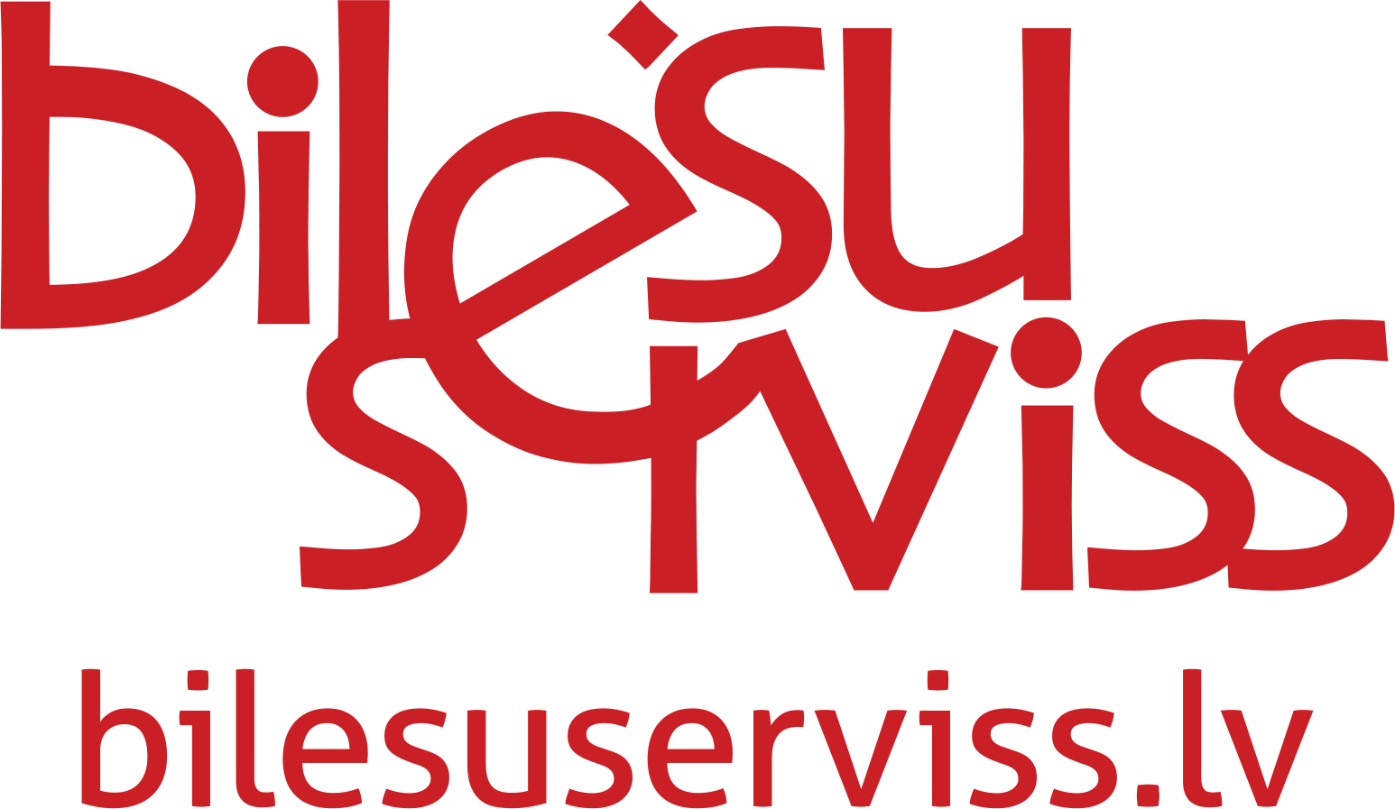

Limited liability company ”BILESU SERVISS”
Legal address: Rupniecibas street 34a-3a, Riga, LV – 1045, Reg.No.40003493078
Office address: Rupniecibas street 34a-3a, Riga, LV – 1045
Phone +371 66100335, e-mail: info@bilesuserviss.lv
Home page address www.bilesuserviss.lv

ORDER FOR TICKETS AND MONEY RETURN
/WITH MONEY TRANSFER INTO ACCOUNT/

Date:
Name of concert:
Date of concert:
Information of buyer
Name, surname:
Home address:
E-mail:
Phone number:
Bank account number (IBAN):
Bank swift/bic code:
Name of bank:
Address of bank:
Information of tickets
Price:
Quantity:
*** Tickets ID numbers:
Purchase date:
Other additional information of buyer:
(Comfirmation order No.)
*** ID - The number of eight black color figures on the upper left side of the ticket.

The transfer will be made in Euro according to currency rate LVL/EUR 0.702804

BILESU SERVISS annotations:
/Piezīmes: saņemšana, apstiprināšana, uzpirkšana, naudas atgriešana/.
___________________________________________________________________________________________________________________________________________________________________________________________________________________________________________________________________________________________________________________________________________________________________________________________________________________________________________________________________________________________________________________________________________________________________________________________________________________

